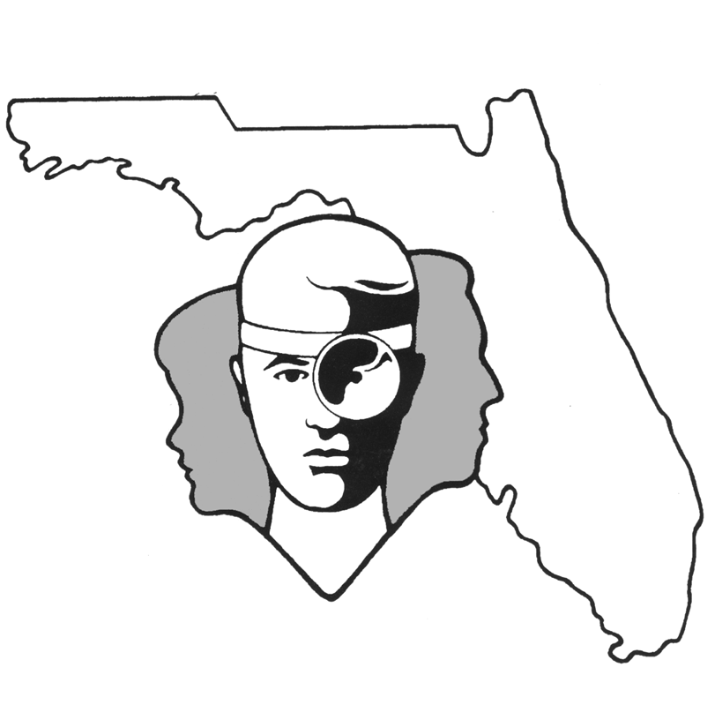
TALLAHASSEE EAR, NOSE & THROAT - HEAD & NECK SURGERY, P.A.

www.TallyENT.com Office Phone: 850-877-0101

PATIENT DISCHARGE INSTRUCTIONS:
MYRINGOTOMIES with VENTILATION TUBE INSERTION

POST-ANESTHETIC CONSIDERATIONS: Anesthesia for the patient was only 15-30 minutes long. They may feel and act sleepy or disoriented for up to four hours. This is generally completely worn off by the afternoon. Certain anesthetics and pain medications may produce nausea and vomiting which usually resolves by the evening of the surgery.

ACTIVITY: The patient is allowed to do as much as they feel like doing. Most patients are unaffected by the surgical procedure after four hours. We would advise that vigorous exercise or swimming not be allowed for the first 48 hours.

DIET: The patient will probably be back to their usual diet by the time they leave the outpatient facility.

WOUND CARE: There is really nothing special that needs to be done. We do not worry about clean water entering the ear, but generally it is best to keep dirty water out of the ears for as long as the tubes are in place. Ear plugs are recommended for swimming in stagnant water, such as a pond. Your surgeon may also recommend using them in lakes, rivers, or the ocean.

MEDICATIONS: Over the counter pain medications (aspirin, Motrin, Advil, Ibuprofen, Tylenol, etc.) may be taken as needed for pain. The patient may be given ear drops to use post operatively. Use as directed by your doctor. These drops may be eye drops, but they should be used in the ear.

SYMPTOMS TO EXPECT: Drainage from the ears can be expected, but should resolve in two to three days. If green, yellow, purulent or foul-smelling drainage occurs from your child's ears several weeks after the procedure; you merely need to contact your doctor for prescribed ear drops. The eardrops should be continued only as long as there is drainage, but your child should refrain from swimming until the drainage has stopped. Please try to remember which ear drains so that we can keep track of this in your child's medical chart.

WHEN TO CALL YOUR PHYSICIAN:
- A temperature over 101.5 degrees does not respond to over the counter pain medications; or persists at this level for more than two nights
- Drainage from the ears lasting longer than two to three days; or if it does not clear within three to four days after using eardrops, an appropriate culture may need to be taken

SPECIAL INSTRUCTIONS: A postoperative appointment has already been scheduled. Please refer to your Surgery Information Sheet or call the office to confirm the appointment date and time. We strongly suggest that a responsible adult be with the surgical patient the rest of the day and also during the night for the surgical patient's protection and safety. Please contact your physician immediately if you have an emergent situation. If you find that you cannot contact them, but feel that your signs and symptoms warrant a physician's attention, go to the nearest emergency room. For non-emergent questions (i.e. appointments or general questions), please call during normal office hours.

